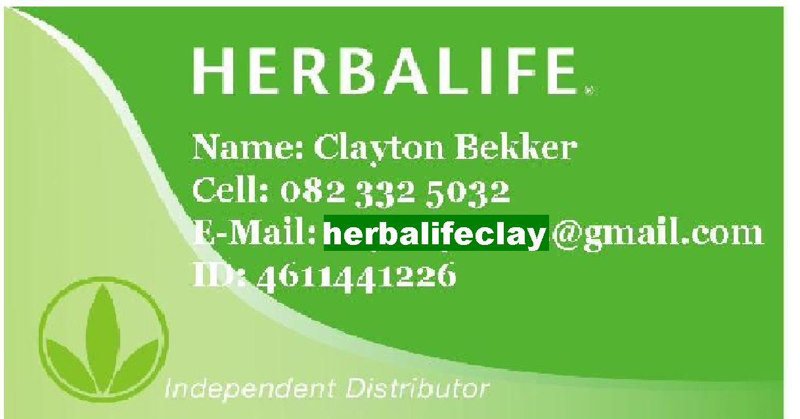HERBALIFE PRODUCTS & PRICE L IST
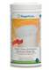  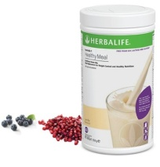 |  | Formula 1 - Nutritional Protein Drink Mix  Created with advanced food technology, the specially formulated, unique blend of ingredients in the Herbalife products provides easily absorbed, high quality soy protein, carbohydrates, vitamins, mineral, dietary fibers and herbs. The antioxidant nutrients Vitamin C, E and selenium can help protect against cell damage.  Drink a Formula 1 shake, and you’ll feel full and satisfied and energetic. Each serving packs nine grams of protein & is Rich in dietary fiber. Loaded with vitamins and minerals, including the a ntioxidant vitamins A, C a E. Provides dietary amino acids the body cannot produce on its own.  -------------------------------------------------------------------------------------------------------------------  The F1 family gets a new addition!  Introducing the new F1 Free From shake - made free from gluten, lactose and soy!
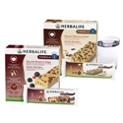 |  | Box of 7 Formula 1 Express Bars  Balanced essential nutrients for a complete healthy meal replacement. Soy Protein and plant based carbohydrates for sustained energy and to keep you fuller for longer. All the nutrients needed with 207kcal. Low GI. All the nutrition of our Formula 1 shake in the convenience of a delicious tasting bar. When trying to lose or manage your weight, it’s important to maintain a nutritionally balanced diet which can be difficult if convenient and tasty solutions are out of reach. A healthy meal like Herbalife Formula 1 Shake or Formula 1 Express Healthy Meal Bar keep your caloric intake down to avoid putting on extra weight, while also providing you essential vitamins and minerals, long lasting carbohydrate and protein for energy to help feel fuller for longer. It comes in two flavours:- chocolate chip and red berry and yoghurt
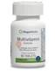 |  | Formula 2 - Multivitamin Complex  A daily multivitamin for long-term good health. Stress, a poor diet and exposure to pollutants can rob your body of essential nutrients. As a result, you may look and feel tired, get sick easily or have difficulty losing excess weight. Includes antioxidant vitamins C, E, beta-carotene and selenium, to help protect cells from free-radicals. Supplies B vitamins, including folic acid, B6 and B12, which are essential for energy production and help maintain healthy homocysteine levels that are already within a normal range for cardiovascular health. Studies show adequate folic acid helps prevent neural tube defects in pregnant women. Herbalife Formula 2 Multivitamin Complex products contain 133 mcg of folic acid per tablet.
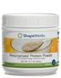 |  | Formula 3 - Protein Powder Supplement Feed your body the proper balance of protein to keep your weight loss on track with this supplemental powder. It contains soy protein, which can help maintain healthy cholesterol levels. Contains whey protein, rich in cystine and methionine, which is vital to muscle development. Has no fat, sugar, carbohydrates, yeast, cholesterol, salt, lactose, sweeteners or artificial colours. Protein is an essential part of every cell in the body and is important in the role cells play in maintaining a healthy immune system, vibrant skin, strong hair and muscle growth. With muscle growth, comes an increase in lean body mass and heightened metabolism. Protein is also crucial to instilling a feeling of fullness and satisfaction in the body, making weight-loss efforts easier with Herbalife products
Fibre and Herb Tablets
Combining oat bran and selected herbs, which work together to encourage the efficient elimination of waste products form the food we eat, for a cleaner digestive system. A ‘cleaner’ digestive system can function more effectively and also helps to ensure better absorption of nutrients from the food we eat. These Herbalife Products cleanse the villi of the small intestine to allow your body to absorb nutrition.
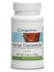 |  | Herbal Concentrate  A refreshing and invigorating herbal beverage. Combining ancient herbal wisdom with modern-day ingenuity, Herbalife has carefully formulated Thermojetics Instant Herbal Beverage to provide a versatile alternative to traditional beverages. Thermojetics Herbalife products are a unique all natural herbal product containing no preservatives and no animal products. Further helps to speed up the weight loss and further curbs and controls our appetite, and massively increases energy!
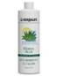 |  | Herbal Aloe Concentrate  Pure, wholesome refreshing beverage that helps soothe the digestive system; Assists with heartburn, ulcers & indigestion – Assists the natural self cleansing action of the body. Speeds up weight loss process. Stress, coffee, cigarette smoke and poor eating habits can upset the stomach and impair digestion. Aloe Herbalife products bring relief. The aloe plant is known to contain 75 beneficial substances, including enzymes, vitamins, minerals and amino acids. Herbal Aloe Drink combines the goodness of aloe, with a delicious citrus twist for a healthy digestive system.
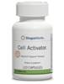 |  | Cell Activator  Helps to ensure your cells to absorb essential nutrients from the food and supplements you consume. Each cell in the body has to perform two main functions:  1 - Releasing energy in the form of ATP through a series of biochemical processes known as the Krebs Cycle and Oxidative Phosphorylation.  2 Using energy to perform its function, whether it is a brain cell, liver cell or lung cell. Without a regular supply of essential nutrients, this release of energy at a cellular level can be inhibited. Because of poor diet, poor digestion or high levels of stress energy production can be reduced and may leave our cells without sufficient energy to function properly.
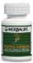 |  | Thermo Complete  Herbalife products have an appetite suppressant & weight control with a massive energy boost. Thermo Complete contains great blend of herbs to assist with weight control. Concept THERMOGENESIS – Changing the balance of energy consumption. Favours increased energy utilization – Ergogenic herbs enhance athletic performance. Appetite control – Energy boost – increase in activity level
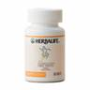 |  | Lipo Bond  This scientifically advanced formula is derived from all-natural ingredients and is designed to aid in effective weight control. Scientific & nutritional experts recommend an increase in dietary fiber and lower intake of saturated fats and calories to help maintain health and regulate weight. Lipo-bond contains a special ingredient to assist the emulsification of fats for digestion, and fiber to help flush wastes from the digestive tract. Lipo-Bond contains a unique blend of ingredients that combines with the food you eat so that your body absorbs less fat. These Herbalife products also help to create a feeling of fullness.
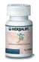 |  | Herbal Complex  The Vitamin/Mineral/Herbal Formula also reduces the appearance of cellulite. With its high concentration of herbs, it helps promote the circulation in the body and has a diuretic effect on these fat cells, reduces fat pockets, helps promote centimetre loss immediately, helps reduce excess fluid and restores ones vitamin C, potassium and iron. Micro nutrient supplementation is a precise science involving rigorous quality control during manufacture.
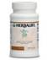 |  | Nature’s Raw Guarana (NRG)  Herbalife has captured the qualities of guarana in this drink. Its essence is derived from the same guarana source used for centuries by the Amazon Indians. Many parents have reported that NRG has assisted dramatically in children using the common prescription drug “RITALIN”. No more mid – afternoon letdowns. Herbalife products help improve concentration and mental alertness.
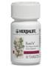 |  | Rose – Ox  RoseOx helps protect the body’s cells and enhances the benefits of other antioxidants by supporting the immune system. This unique formula creates an antioxidant cascade effect, helping to regenerate other antioxidants and provide a potent, longer-lasting supplement. Helps protect the body’s immune system. Our cells produce thousands of free radicals every day. Free radicals from the environment occur as an effect of stress, pollution and unhealthy eating habits. Without proper nutrition, oxidation can contribute to any number of debilitating diseases, including cancer, heart disease and aging.
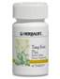  R200.00 |  | Tang Kuei  A targeted product for women designed to alleviate the discomfort associated with Pre-menstrual Syndrome. Tang Kuei increases pelvic blood circulation and relieves uterine spasms and helps regulate and balance hormones throughout the menstrual cycle. Tang Kuei has several other actions including being a Blood cleanser, and muscle relaxant with mild analgesic and anti-inflammatory properties. General applications of Tang Kuei include the relief of general tension and to help people relax and sleep better. Tank Kuei Herbalife Products can be used as an adjunct to pain control.
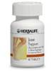 |  | Joint Support with Glucosamine  Nutritional supplement for healthy joints and muscles.* Joint Support–Glucosamine with Herbs is a dietary supplement for joints and muscles that ache due to excessive wear and tear.* It’s formulated with glucosamine sulfate, a compound produced by the body that contributes to the natural cushioning effect of cartilage. Helps build healthy cartilage to cushion & enhance joint health & formulated to ease discomfort in joints and muscles.* In combination, these nutrients help protect joints against the wear-and-tear that occur over the years.
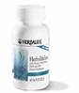 |  | Herbalifeline  Medical experts and some studies suggest that Omega-3 fatty acids can help support proper functioning of the heart. Herbalife products contain 50 % more Omega-3 fatty acids. Essential oils of thyme, peppermint and clove help keep the oil fresh and reduce indigestion. Studies demonstrate reduction of stroke, particularly in women. Another study shows Reduced risk of blockage of vein grafts in people who have had coronary artery bypass surgery. In addition to research showing results in combating a variety of ills, from cancer to heart disease and even psychiatric conditions, a recent study indicates they may offer protection from colon cancer. Also shown positive effects against prostate, breast and pancreas cancer cell lines.
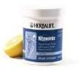 |  | Niteworks  The result of a collaboration between Herbalife and Nobel Laureate Dr. Louis Ignarro. Niteworks™ is a revolutionary dietary supplement containing an exclusive blend of L-Arginine and L-Citrulline with other ingredients that trigger the production of healthful Nitric Oxide. This is important, because as you age, production of Nitric Oxide, the naturally occurring compound which keeps blood vessels young and flexible, declines. And if cholesterol-laden plaque builds up in an artery, the opening shrinks, blood flow decreases and can even be blocked with formation of a clot, causing heart attack or stroke. Dilates & expands arteries and regulates cell function throughout the body. Improves circulation to the body’s vital organs, including heart and brain.
Box of 14  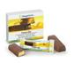 |  | Protein Bars  The ideal low calorie, high protein, great tasting snack.
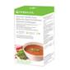 |  | Gourmet Tomato Soup A hot, savoury and nutritious healthy snack that's easy to make. It combines the latest in nutritional science with prebiotic inulin fibre and naturally occuring tomato lycopene. Popular flavours basil and oregano offer you a taste of the Mediterranean.  KEY BENEFITS  - Scientifically advanced; contains prebiotic fibre inulin to support digestive health, and naturally occurring antioxidant lycopene from tomatoes  - Eight times the protein of regular tomato soup*  - High in protein and fibre to help you feel fuller for longer and provide satiety  - Only 104 calories to help you manage your caloric intake  - Ideal as part of your 5 small meal plan  - Suitable for vegetarians  WHY DO YOU NEED IT?  Soup is an ideal savoury snack for any weight management or healthy nutrition programme. It is a high volume, low energy food that provides the feeling of satiety and fullness without the extra calories, often found in larger meals or less healthy, convenient snacks.
Formula 1 Sport Healthy Meal for Athletes  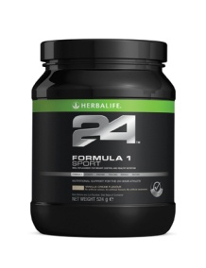 |  | Overview  Gain confidence from your pre-workout nourishment. Balanced with carbohydrates, proteins, vitamins, and minerals, Formula 1 Sport establishes a solid nutritional foundation for performance while being convenient to consume.  Key Benefits  Milk protein supports lean muscle mass Carbohydrate blend to provide immediate and sustained energy Antioxidant protection from vitamins C, E and selenium Contains L-Glutamine  SKU Product/Type Retail Price  1432 Vanilla Cream Flavour 524 g 1_ 524g container 524 g
Prolong  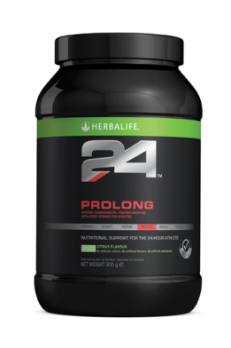 |  | Overview  Nutrition is vital to power your performance. Prolong’s dual-source blend of carbohydrates facilitates caloric utilisation for sustained performance. Whey protein acts as a protective measure, reducing muscle breakdown during prolonged exercise. Prolong is easy-to-drink with a light, subtle flavour.  Key Benefits  Sustain performance with dual-source carbohydrates, protein and sodium With protein to support muscle synthesis and recovery B vitamins, including B1 and B12, support energy metabolism 100% RDA of vitamin C helps combat free radicals Isotonic formula for efficient carbohydrate and fluid uptake  SKU Product/Type Retail Price  1435 Citrus Flavour 900g 1 container 900g
Rebuild Endurance Speed Recovery,Rebuild Muscle  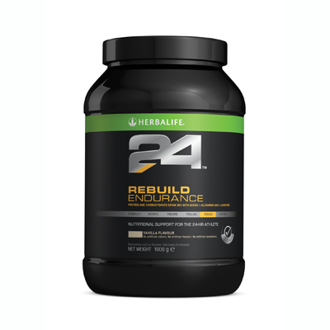 |  | Overview  Recovering after intense aerobic activity requires both replenishing glycogen and rebuilding muscle. Rebuild Endurance contains an engineered blend of carbohydrates to help jump-start glycogen replenishment. A selected blend of milk protein, glutamine and L-Carnitine aid muscle recovery and help support the immune system. Quickly metabolised whey protein, and slower-release casein protein create a rapid and sustained muscle building state.  Key Benefits  Rich in protein, from milk protein concentrate and whey protein isolate Designed to help speed recovery with a unique carbohydrate-protein blend to support muscle glycogen replenishment and rebuild muscle during the critical post-exercise period L-Glutamine to support the immune system, which becomes stressed by exercise Includes L-Carnitine to aid muscle metabolism and recovery after exercise  Details  Rebuild Endurance is developed by experts in sports nutrition. This unique high protein sports drink is enriched with L-Glutamine and L-Carnitine for post high intensity aerobic exercise. The 3.5:1 ratio of carbohydrates to protein is designed to replenish glycogen and rebuild muscle, reducing recovery time as your body works to regenerate itself.  SKU Product/Type Retail Price  1436 Vanilla Flavour 1 Container 1000g
H3O Pro™  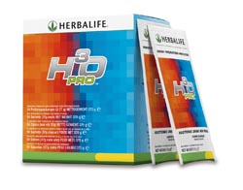 |  | Overview  H3O Pro™ is an isotonic drink designed to meet the body's demands for hydration and energy. Clean and great tasting, H3O Pro™ is for fitness minded or serious athletes wanting an exceptional performance.  Key Benefits  Rapid hydration: replaces essential salts to help you avoid the negative affects of dehydration Immediate and sustained energy: no ‘spikes and crashes’ in energy levels Absorption: 5 energy-releasing B vitamins help your body to absorb the nutrients in H3O Pro Antioxidant protection: to help protect the body from free radicals Taste: Refreshing, subtle and clean with a hint of tangy lemon No artificial sweeteners, flavours or preservatives  SKU Product/Type Retail Price  2646 Lemon Lime 10 sachets per box
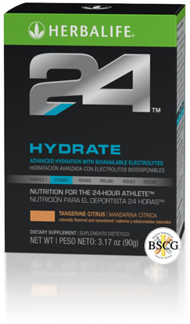 |  | Hydrate Supports Hydration with Electrolytes  Overview  Hydration is key for performance. Replenish your body with electrolytes to enhance fluid absorption, ensuring you are hydrated and ready to perform at your best. Hydrate contains less than 1 g of sugar and carbohydrate-metabolism supporting B Vitamins. When mixed with water, it’s the perfect any-time hydration option  Key Benefits  Hydration anytime, for anyone 100% RDA of the antioxidant vitamin C Contains the electrolytes sodium, calcium and magnesium for rapid body fluid restoration Low calorie and sugar free Source of energy supporting B vitamins including B1 and B12  SKU Product/Type Details Volume Point Retail Price  1433 Orange Flavour 20 stick packs 20 stick packs per box 20 x 5.3g 22.20
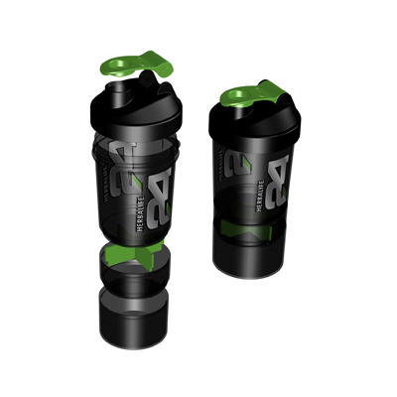 |  | Herbalife24 Super Shaker  Key Benefits  Innovative whisk ball - Drop in the whisk ball before shaking your way to a smooth, creamy shake! 2 Additional compartments - Just screw the extra compartments onto the shaker bottle to keep all your Herbalife needs in one place!  - Use one compartment with the separator, to organize and carry your tablets on the go.  - Use the other compartment to store powder for your next shake
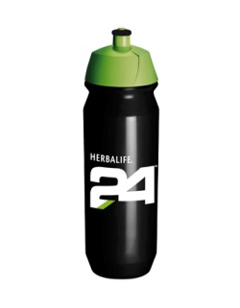 |  | Herbalife24 Sports Bottle 500cc  Herbalife24 Sport Bottle 500cc  R80-00ea

Nourifusion
Complete Skin Care
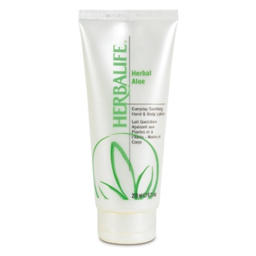 |  | Product Overview  Product Details  Hand & Body Lotion 200 ml  Overview  Light and non-greasy, this soothing Hand and Body Lotion has a mild and fresh scent, which is ideal for everyday use.  Key Benefits  • Light and non-greasy lotion to leave your body feeling silky and soft  Details  Climate, hard water and pollution can dry out skin. Take steps to maintain moisture with this fast-penetrating and nourishing formula made from whole-leaf aloe and select extracts that keep skin moist and smooth.  Usage  Apply generously to the skin wherever needed.  Fast Facts  Fast Facts
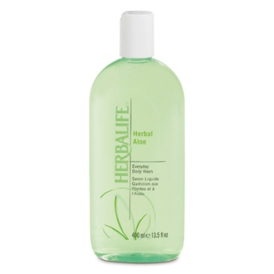 |  | Product Overview  Product Details  Everyday Body Wash 400ml  Overview  Hydrates and cleanses the skin from head to toe in a rich foam lather formulated from whole aloe leaf.  Key Benefits  • Cleanses and hydrates your skin in a rich foam lather  Details  A daily body wash with aloe vera, chamomile and calendula to cleanse and relieve dry skin without stripping the body's natural oils. Can be used on a sponge or loofah in the shower to create foaming lather.  Usage  Massage directly onto wet skin or apply using a wash cloth. Rinse thoroughly.  Fast Facts  Fast Facts
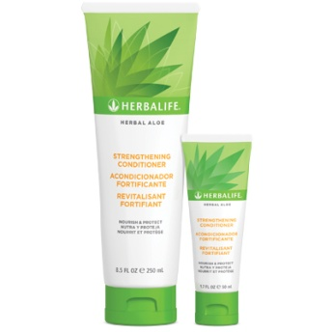 |  | Product Overview  Product Details  Herbal Aloe Strengthening Conditioner 250ml  Overview  Strengthen and repair your hair with a sulfate-free advanced protein-infused conditioner that reduces breakage by 90%  Key Benefits  •Leaves hair up to 10 times stronger after just one use. •Reduces hair breakage by 90%. Hydrolyzed wheat protein helps protect, repair and strengthen.  Details  Transform your hair with this advanced protein-infused conditioner that strengthens strands for a softer, silkier feel after just one use.* Color-preserving formula  Usage  Massage into hair. Leave on up to three minutes. Rinse thoroughly  Fast Facts  Contains the following key ingredients: •Aloe vera to moisturize hair •Hydrolyzed wheat protein to strengthen hair
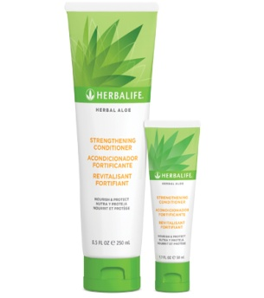 |  | Product Overview  Product Details  Herbal Aloe Strengthening Shampoo 250ml  Overview  Strengthen and repair your hair with a sulfate-free strengthening shampoo that leaves hair 10 times stronger after just one use and reduces breakage by 90%  Key Benefits  Leaves hair up to 10 times stronger after just one use Reduces hair breakage by 90% Hydrolyzed wheat protein helps protect, repair and strengthen  Details  Microproteins strengthen hair, while gentle cleansers create a luxurious lather. Individual strands are repaired revealing softer, smoother, silkier hair. Color-preserving formula  Usage  Apply,lather and rinse  Fast Facts  Contains the following key ingredients: •Aloe vera to moisturize hair •Hydrolyzed wheat protein to strengthen hair
 | 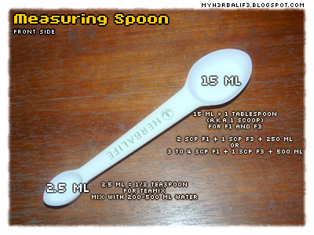

Measuring Spoon
Custom designed for Herbalife products, it is four measuring spoons rolled into one. Measurements include: tablespoon, teaspoon, ½ teaspoon and ¼ teaspoon.
R10-00ea
Herbalife Proudly Introduces A New Kind Of Energy! Liftoff® is an effervescent energy drink tablet that does more than give you your body a boost—it’ll shift your mind into high gear!* With an exclusive energy blend of taurine, guarana, caffeine, Panax ginseng and Ginkgo biloba, Liftoff® fights fatigue and improves mental performance.* Liftoff® also contains 100% of your daily supply of antioxidant Vitamin C and more than 100% of your Vitamins B6 and B12 for enhanced energy production.* Try both refreshing flavors, Ignite-Me Orange and Lemon-Lime Blast, today. Now available in two convenient sizes: 10 tablets and 30 tablets. Helps fight physical and mental fatigue.*Helps you stay focused for improved concentration.*
Flavors: Orange and Lemon Lime.

CUSTOMER ORDER FORM  HERBALIFE WEIGHT CONTROL NUTRITIONAL PRODUCTS | R |  | Qty | R
ShapeWorks Quick start program = A + B + C + D | 925.40
A Formula 1 Nutritional Shake Mix : Van /Choc / Strawb / Tropical | 343.35
Formula 1 Nutritional Shake Mix : Van- FREE FROM Lactose, Soy and Gluten | 377.67
B Formula 2 Multivitamin Complex ‘Nutrient Support’ | 159.06
C Formula 3 Personalised Protein Powder ‘Protein Power’ | 280.27
D Fibre & Herb ‘Cleanse and de-toxify body’ | 142.73
Healthy Breakfast = Herbal Aloe + Thermojetics + Formula 1 Nutritional Shake Mix | 919.31
Single Sachet | 18.90
Gourmet Tomato Soup ‘Delicious Savory hot or cold’ | 326.99
HBL 24 F1 Sport-Vanilla | 516.15
HBL 24 Rebuild Endurance-Vanilla | 729.45
HBL 24 Hydrate- Orange | 342.34
HBL 24 Prolong-Citrus | 492.45
HBL 24 Rebuild Strength- Chocolate | 815.92
F1 Express Bar -Chocolate Chip or Yoghurt and Berry( pack 7) ‘Healthy Meal bar’ | 159.68
Lipobond ‘Remove excess oil from food’ | 201.93
Herbal Complex ’Rid water retention & cellulite’ | 204.51
Thermojetics Herbal Concentrate - 100g ‘Burns fat. Gives great energy’ | 410.25
Thermojetics Herbal Concentrate - 50g Original / Lemon / Berry / Peach | 233.09
NEW Liftoff – Ignite-Me Orange / Lemon-Lime Blast ‘Fizz, Focus, Fuel Good’ | 284.04
NRG Tea - 60g ‘Strength – Mind & Body Power’ | 181.97
Herbal Aloe Concentrate ‘Indigestion /Stomach soother’ | 342.87
Herbal Aloe Concentrate Mango Large ‘Indigestion /Stomach soother’ | 342.87
Rose Ox ‘Healer / Antioxidant’ | 270.11
Tang Kuei ‘Mood Stabiliser, Muscle relaxer’ | 196.43
Herbalifeline ‘Save your life by protecting your heart’ | 368.06
Joint Support ‘Benefits aching joints & muscles’ | 299.20
Thermo Complete ‘Curbs appetite & invigorates’ | 445.02
Cell Activator ‘Helps your body’s cells utilise essential nutrients’ | 265.12
Niteworks ‘Supports vascular & circulatory health’ | 515.07
Protein Bars (14 per pack) Vanilla / Chocolate / Lemon ‘Guilt free snack’ | 207.29
H3O Pro ‘Isotonic Drink’ |  | 193.02

Total Amount

We give free follow-up and support.
.

All our products come
With a NO RISK
30 DAY
MONEY BACK GUARANTEE !!!
.

Independent Herbalife Distributor
Clayton Bekker
082 332 5032
www.walkingraces.co.za
Name
Address

Tel | (Cell) (Work)
PAYMENT OPTIONS: CASH ELECTRONIC TRANSFER
CP Bekker, FNB Bank Savings 621 8149 2209, Branch code: 22 02 28.
NOURIFUSION RANGE
NouriFusion Normal to Dry (Lotion Cleanser, Toner and Moisturizer SPF 15) | 678.26
Nourifusion Lotion Norm/dry or N/Oily | 265.12
Lotion Cleanser for Normal to Dry skin | 206.57
Toner for Normal to Dry skin | 206.57
NouriFusion Normal to Oily stem (Lotion Cleanser, Toner and Moisturizer SPF 15) | 678.26
Lotion Cleanser for Normal to Oily skin | 265.12
Toner for Normal to Oily skin | 206.57
NouriFusion Night Cream | 500.96
NouriFusion Eye Cream | 325.38
NouriFusion Eye Gel | 325.38
NouriFusion Clarifying Mask | 295.58
NouriFusion Moisture Mask | 295.58
NouriFusion Facial Scrub | 295.58
SPECIALITY / TREATMENT SKIN CARE PRODUCTS
Body Buffing Lotion | 197.13
Body Contouring Cream | 332.08
Radiant C Skin Booster | 306.77
Radiant C Face Quencher | 92.96
Radiant C Scrub Cleanser | 223.79
Radiant C Lotion SPF15 | 308.72
HAIR AND BODY CARE FOR ALL THE FAMILY
Herbal Aloe Hand & Body Wash | 122.92
Herbal Aloe Soothing Gel | 122.15
Herbal Aloe Everyday Soothing Hand and Body Lotion | 122.15
Herbal Aloe Strengthening Shampoo | 115.68
Herbal Aloe Strengthening Conditioner | 115.68
Herbal Aloe Hand & Body Wash | 82.45
FRAGRANCES
Woman - Fragrance | 297.49
Man - Fragrance | 297.49
Soul Fragrance for Men | 462.93
Heart Fragrance for Woman | 425.75
SKIN ACTIVATOR RANGE
Lotion Oval 50ml Tube | 662.78
Decolletage Cream Pump 50ml | 662.78
Night Cream Jar 50ml | 590.46
Lip Treatment | 280.62
TOTAL

